Microgravity Drone Experiment Platform
Group 23
Adam Brockmeier-EE
Andrew Brahim-EE
Jacob Knepper-CE
Jourdain Francis-CE
Sponsor: Northrop Grumman (NGC)

Narrative Description

The need for low cost Microgravity (reduced gravity) experimentation platforms exist for researchers who may not have access to drop tower facilities or funds to carry out existing methods of collecting data in reduced gravity environments. Parabolic flight requires modified commercial airline equipment researchers do not have, and renting such a flight or service is not a feasible cost for the average university faculty scholar or researcher. Various drop towers exist throughout the world that allow reduced gravity experiments over the course of several seconds, but these facilities are not always feasible for researchers due to travel costs and expenses, coupled with difficulty in securing a reservation for tower use. Lastly, sending up a payload to the ISS for reduced gravity conditions incurs great costs and logistics, not always working within the timeframe of the researcher.

Ergo, the proposal is made for a drone based system to carry a payload (comprised of a vacuum chamber and sensors) for experimentation at predetermined altitudes for free fall drops. This project seeks to create reduced gravity conditions via free fall of a drone for a length of time necessary for payload experiments to be recorded. The payload environment must also be recorded and instrumentation such as drag, acceleration, temperature, and velocity are necessary. A video recorder will be used to capture particle movements. Specifically, Electrical and Computer Engineers will be designing the embedded system required for sensor data logging in addition to developing the control system. Interdisciplinary team effort may be necessary to develop the power distribution system of the drone. Mechanical and Aerospace Engineering (MAE) team will be in charge of aircraft design to meet the stringent altitude and drag requirements of the project. The end objective of this project is to give the researcher an inexpensive, easy to use, near on demand means of conducting reduced gravity experiments.

Requirements Specifications
The project requirements are as follows:
- Budget must be constrained as an affordable alternative to other microgravity experimentation methods, as well as constraints set by the sponsor
- Freefall/microgravity conditions must be met for 5-25 seconds per flight
- Drone must be able to achieve starting altitude of 4,000-5,000m to perform freefall
- Drone must be able to recover from freefall and land the payload safely
- Telemetry must be able to relay relevant information to pilot and customer on the ground
- Microgravity conditions/sensory data must be logged to record all experimental variables
- Flight path must be as repeatable as possible for experimental consistency
- Clean accelerometer microgravity data preferred (as close to 1*10^-6 g)
House of Quality chart

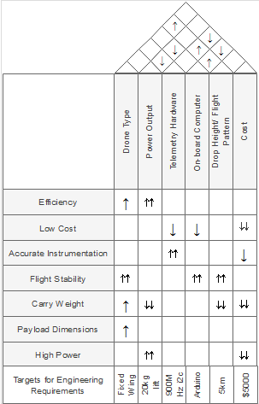
Figure 1: House of Quality diagram outlines the correlation between the different engineering and consumer requirements for the microgravity drone project. The last row states our desired outcomes for each consumer requirement.

Block Diagrams

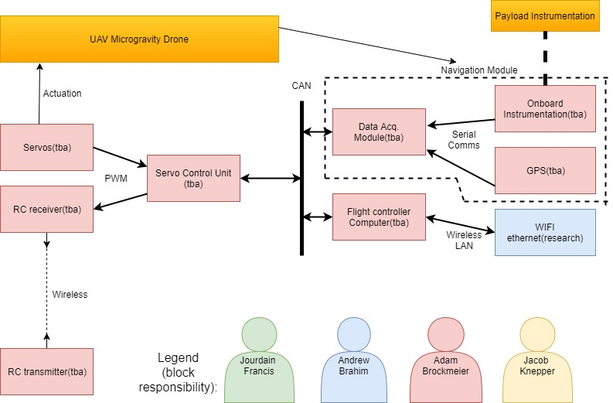

Figure 2a: Group Assignment and role matrix. This diagrams shapes the necessary delegation for the hardware and software requirements of the drone
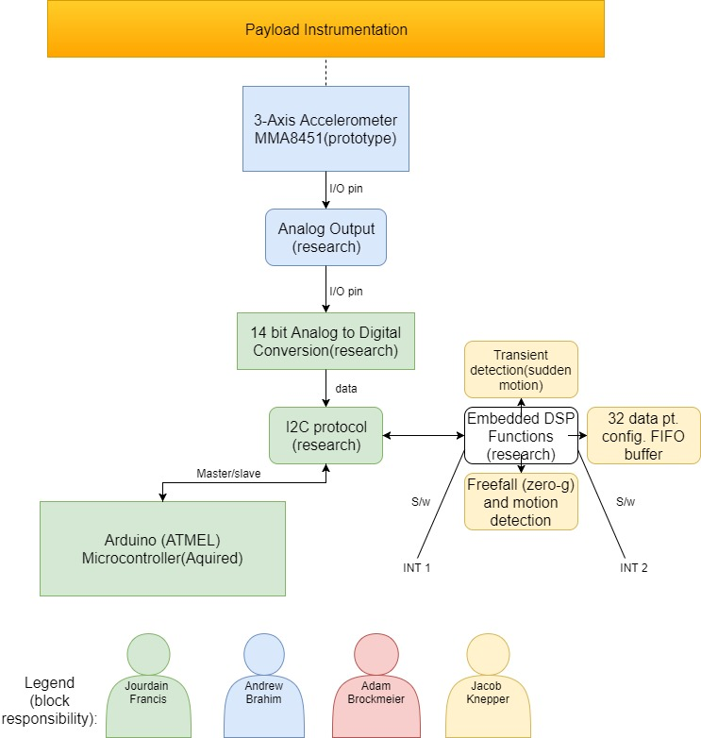

Figure 2b: Payload instrumentation diagram. This shows and delegates the personal requirements of each team member in regards to payload sensor information, analysis, and calibration.

Budget and Financing estimates

The project budget is heavily dependent on how our sponsors and interdisciplinary teammates decide to proceed with the design of the drone. Multirotor vs fixed wing, electric vs nitro engine, each style of drone has a unique price point to achieve our goal. The size of the payload also directly correlates to overall scaling of the cost of the craft. A payload of less than 1kg could be subjected to these microgravity conditions for ideally less than $800, but this will not be sufficient for our experiment. I estimate that a payload of 5-10kg would need to be flown by a fixed-wing craft with about a 4,500 mm wingspan. This would cost around $4,100, based upon the specs of a Mugin T-Tail UAV. The Pixhawk flight controller system including GPS, telemetry and other hardware would cost an additional $270. If a battery is required simply to power the electronics and sensors in the craft it could be purchased for approximately $20-30 depending on size and brand. This is running under the assumption that a nitro-powered engine will be driving the craft as with the Mugin. Various other hardware to assemble the craft (screws, 3D printed parts, etc.) will cost around $20-50.

A prototype board and datalog platform with sensors for the system will cost up to $110 at most. An arduino based prototype may cost approximately $30, and the required accelerometer, gyroscope , temperature , humidity, and drag sensors may total $20. A data logging module is required to collect accelerometer information, temperature, humidity, and drag. The combined total cost of the data logging module and micro SD card may total $60. The cost of the vacuum chamber is unknown, as the dimensions are still not specified. It might require a custom-built vacuum chamber to fit within our craft. Due to stringent and custom hardware requirements for the vacuum box, we estimate it could cost upwards of $1000. So far without the cost of the vacuum chamber, the total cost of this project will be an estimated $4,600.

If we incorporate the custom made vacuum chamber cost, the total cost may exceed $5,000. Costs may be incurred to use specialized military training facilities to facilitate microgravity drops or flights and may add to the project cost. The nature of microgravity flight or drops involve high altitude drops or parabolic flight above a ceiling. This introduces an inconvenience that is unavoidable due to the commercial air flight regulations restricting aircraft to certain altitudes and locations. After building the prototype , a custom made PCB is required for the final product. Using services such eagle CAD for board development and schematics, we may incur a $100 fee to use the software.

Semester 1 Milestone table

Deliverable | Customer | Milestone | Length to complete | Steps to complete
Embedded system+sensors-Rev. 1 | NGC | October 30th | 20+ hours | Develop an on -the-ground working prototype
60 pg draft | SD Professor | Nov 3rd | 20 hours | Research, gather sources, collate info  (design specs, etc)
Early flight ready prototype- Rev. 2 | NGC | Nov 15th | 20+ hours | Begin flight testing prototype board+ components
100 pg submission | SD Professor | Nov 17th | 5+ hours | Tables, graphics, prototype version comparison, sensor calibration
Rev. 3 prototype | NGC | Nov 28th | 10 hours | Final prototype ready for full flight test
Final Report | SD Professor | Dec 04 | 10 hours | Report revision, editing, corrections

Semester 2 Milestone Table

Deliverable | Customer | Milestone | Length to Complete | Steps to Complete
PCB + components research and comparison | NGC | Jan 30th 2018 | 10+ hours | Gather components, finalize schematics
PCB Rev.0 | NGC | Feb. 14th 2018 | 20+hours | Build to order PCB
Rev.0 ground test | NGC | March 1st 2018 | 10+hours | Conduct ground test with fully functioning board
Rev.0 flight test | NGC | March 15th 2018 | 10+hours | Conduct flight test with fully functional board
Rev.1 and testing if necessary | NGC | March 30th-April 15th 2018 | 30+ hours | Modify PCB or recalibrate if necessary, additional tests
Final product and report | NGC/Professor | April/May 2018 | 20+hours | Submit presentation forms, conduct presentation before panel

